Cadify Tutorial 2022 00 Install and My First Cadify Publish

C:\Dropbox\Cadify\Tutorials\2022 Tutorials\Tutorial 2022 00 Install Cadify and kick_the_tires

Updated 3 December 2022 by Jørn



SUMMARY:

**1: Install Cadify and login**

**2. Your First Product Published at www.Cadify.no**

2.1: Start NEW PART in Solidworks

2.2: Create your SW Part as a “RAW” Product in Cadify

2.3. Publish your tutorial Product on www.Cadify.no

2.4: Your FIRST Product online at www.Cadify.no

**3. Your First Drawing at www.Cadify.no**

3.1 Reopen your Published Product to edit

3.2: Republish your updated Product with drawing

3.3: Download your First Drawing from the Tabbed section

**1: Install Cadify and login**

**Prerequisite for beta-users:**

* SolidWorks installed on your computer. Our development environment uses SW 2020, but we believe that Cadify may run from SW 2018 to SW 2022. If possible, we recommend the extra effort of changing to SW 2020
* You must have an account at our test environment Ovals.no with credentials as “registered” and “vendor”, which require email and password for login. For beginners, we provide a test account.
* Email from Cadify ( Widemore as, as the legal majority owner of Cadify) with Dropbox link to install files.
* Cadify tutorial files, as applicable to current level and task.

First: Close your SW session, and install lthe CadifySetup.msi in Windows:

After installing Cadify from msi installer, with the usual Windows installations steps, THEN start your SW and your start screen should look like this, with a new SW Task Pane button labeled “C”: Click to start:

The Cadify Task Pane has a “login button”: You must have an account with Cadify BEFORE you log-in, with your site, email and password.

Log-in screen:

IF your credentials are not yet correctly set, please notify the Cadify Team.

Here is what the SW Task Pane looks like when user is logged in correctly, with name displayed:

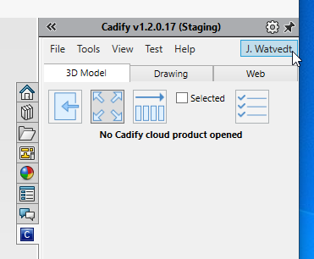

**2. You First Product Published at** [**www.ovalas.no**](http://www.ovalas.no)

**2.1: Start NEW PART in Solidworks**

( In SolidWorks, not the Cadify Task Pane yet)

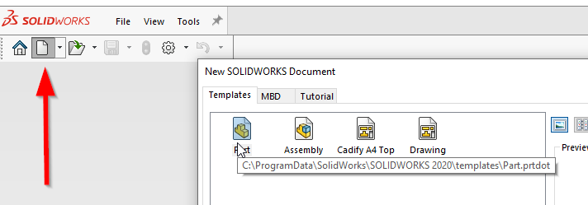

Start a new SKETCH on your Front Plane:

First select and create the classical center rectangle:

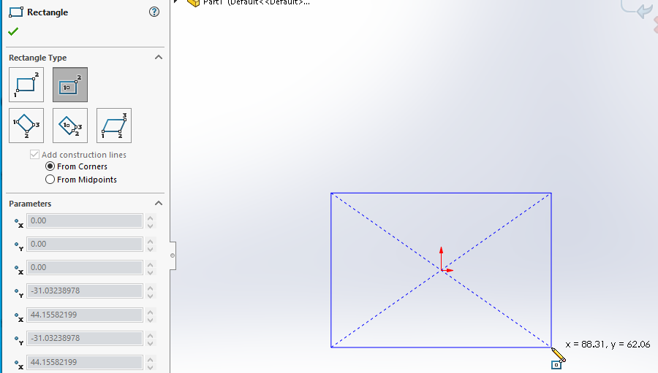

Recommend to turn on “View Dimension Names” and to rename your two dimensions into something that represent length x width and later height of the initial box that we are creating for this Getting Started Tutorial.

Extrude Boss into height D1, rename to “Height” ( Make sure your Show Annotations are on), and renamed feature to “My First Cadify”

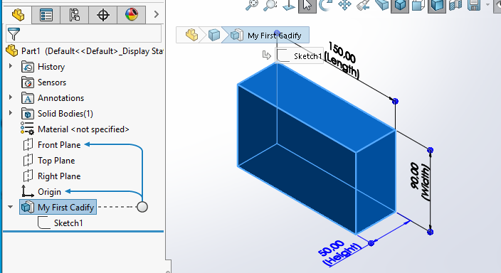

**2.2: Create your SW Part as a Raw Product in Cadify**

Move to Task Pane: In Cadify Task Pane, select File / Save as (raw)

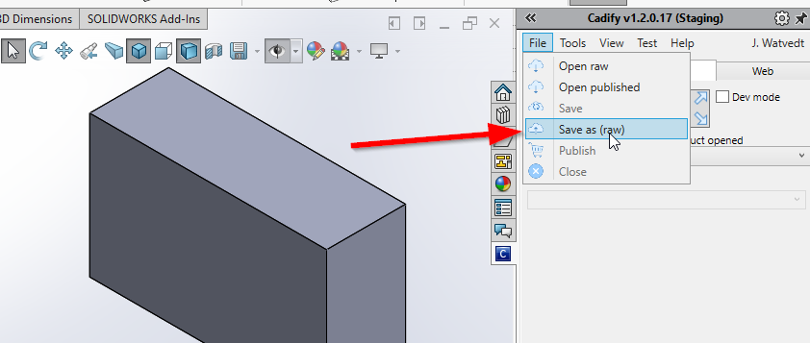

Fill in Product Information as you find fit, note that “SKU” is a Product ID that follows your product throughout Cadify online, for future tracking of your exact version.

STRONGLY recommend that you put your own name or initial in Product Name, making it much simpler to retrieve your product again later ( in the multi-user Ovals space)

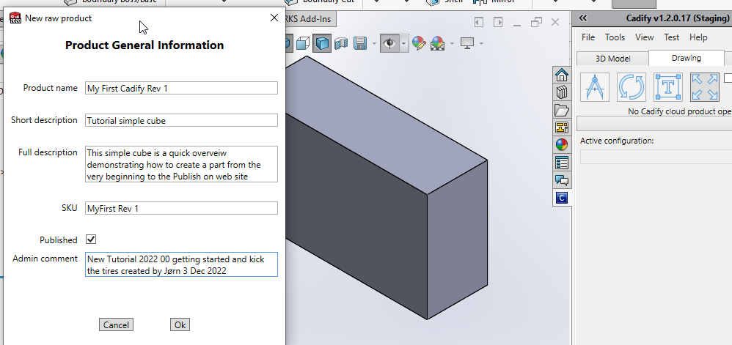

When clicking “OK” you initiate Cadify and start your Cadify Product “raw” session:

Initially, product in your Solidworks session closes, then opens again in Solidworks, but now in the context of Cadify, with an active Cadify Task Pane as follows:

2.2.1: Your Product name is displayed with label “Raw Product”

2.2.2: An Excel workbook is automatically created and synchronized with SolidWorks and your Product. The workbook is pre-formatted and has tab “Cadify MASTER” which is the true database repository for your Product, and has all the properties, settings, referenced, documents and so on that is required for a complete Cadify online product.

2.2.3: The Cadify Task Pane has 3 major categories, namely “tabs”, where we start in the “3D Model” tab

2.2.4: Your product model feature tree root level is shown: Click on root level to expand tree as shown

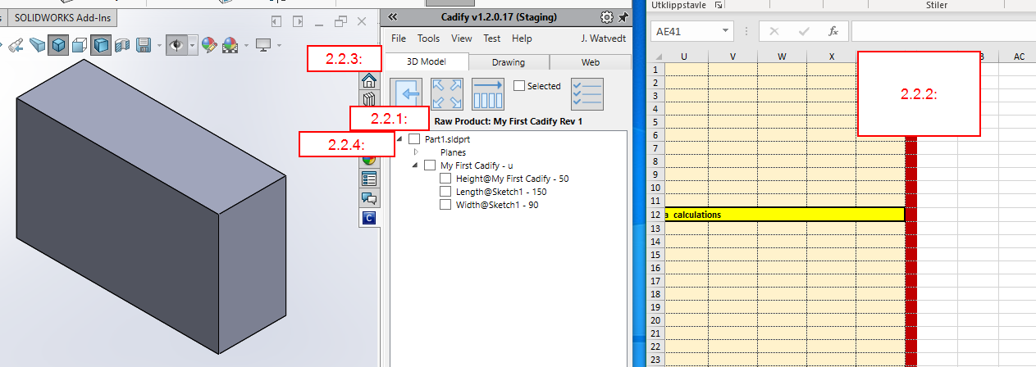

As soon as you Select an item in the Cadify 3D model tree, that parameter is instantly copied into the Cadify Master sheet of the Cadify Work Book, with name and value.

Repeat for all three of your initial Box parameters: Height, Length, Width

Take a minute to inhale this screen: This is an essential part of what Cadify really is: Excel spreadsheet fully integrated into SolidWorks:

* This is NOT DesignTable, this is much more responsive and extremely powerful in comparison
* The Cadify WB is essentially the entire database for presenting and interacting with your product on the web
* You, as the SW engineer, has full access to all of Excel, allowing you to build on your Excel skill and preferences and bring them with you to the Cadify Web Product

Now is a good time to “save” your work_ File/Save:

IMPORTANT: Now you are in the “Cadify Cloud” and your work is saved FIRST on your hard drive, THEN ( in the background) copied into the Cadify Cloud, in preparation of being Published. Now anyone that has credentials with access to your Cadify Site, is ready to become your co-worker and participate in further development of your Raw Product:

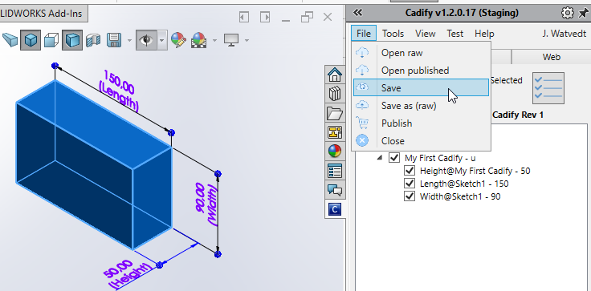

NEXT click on the “Web” tab:

CADIFY MAGIC:

The initially selected parameters are automatically connected to “Cadify Control” that show up first time you click on the “Web” tab. (initially automatic, thereafter manually for changes / additions)

These are fully formatted “control boxed” with default settings from your 3D model, and actually ready to be Published.

You may at any time edit, delete, reorganize, and amend these parameters.

Each of these “green boxes” represent one Cadify Control of type “Spinbox slider”. There are curently 11 different Cadify Controls to select between, for text, lists, radio buttons, images, etc.

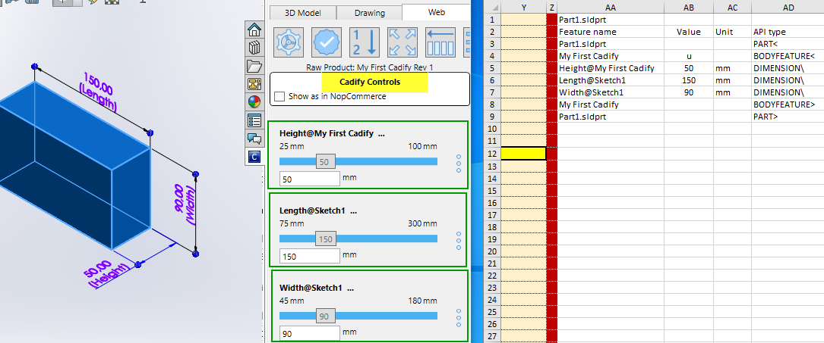

TRY SOME CADIFY MAGIC: Pull the “slider”, watch instant update in the spreadsheet, then click on the “UPDATE” button, and your cube morph into new shape: (kick the tires!!)

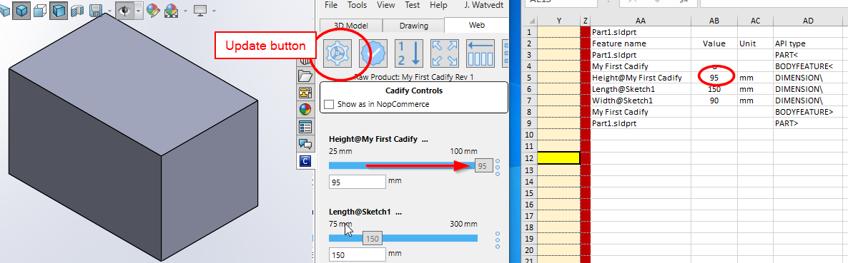

**2.3. Publish your tutorial Product on ovalas.no**

Publish button is right there:

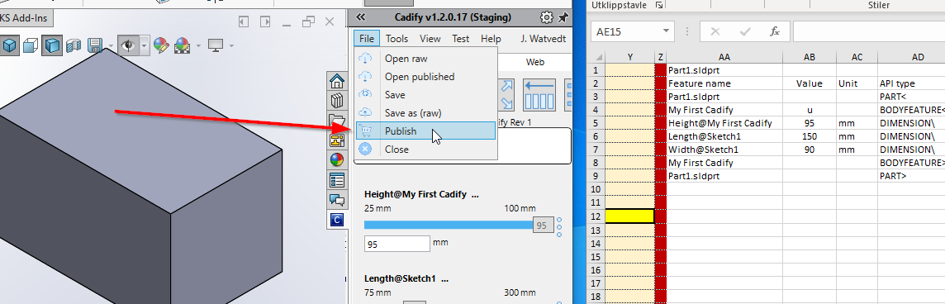

Currently ( December 3rd., 2022,) our staging site ovalas.no has a single web store only. IF there are more stores, all stores that you have access to, are listed:

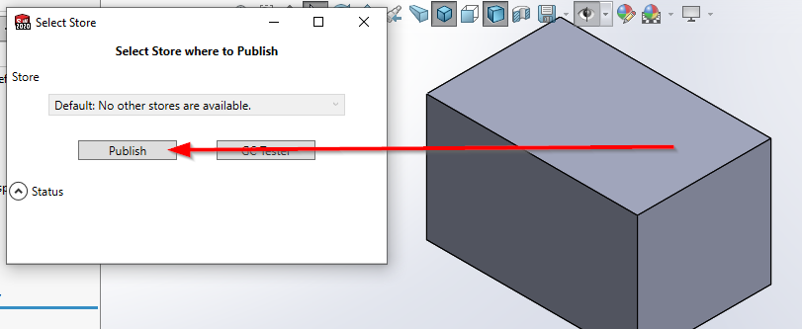

A FULLY AUTOMATED process takes your product onto web into webstore in about 20 seconds ( large product may take several minutes)

When Publish process is finished, your current Cadify Product is closed in SW, and the product “state” is changed from “Raw” to “Published”.

A link for direct access to view your My First on web is right there:

Here is your product on web: THANK YOU for kicking-the-tires and checking out Cadify! You have just scratched the surface of what is possible in Cadify:

(note: due to some scaling issues, you must click on the model, scroll mouse button to reduce size to fit as shown in this printscreen)

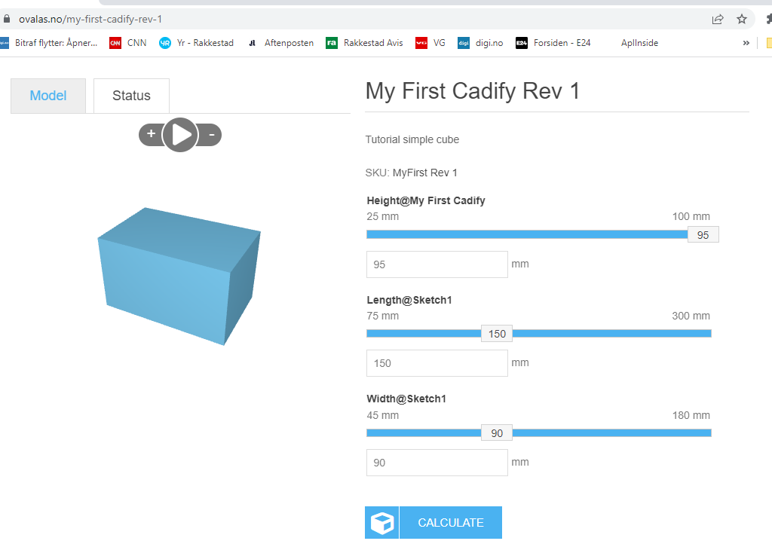

Reality check:

We are still in BETA mode, do not panic if you get an error, just try again: You may have to Open your Raw Project again:

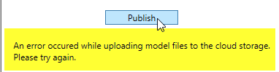

SUCCESSFULLY PUBLISHED: Click on the URL, and you are taken directly to the Product in-store:

( Comment by Jørn: This image is NOT updated for this tutorial)

**2.4: Your FIRST Product online at www.ovalas.no**

Drag sliders, make some changes, click on the “Calculate” button – and watch in the Status how the Cadify process is running:

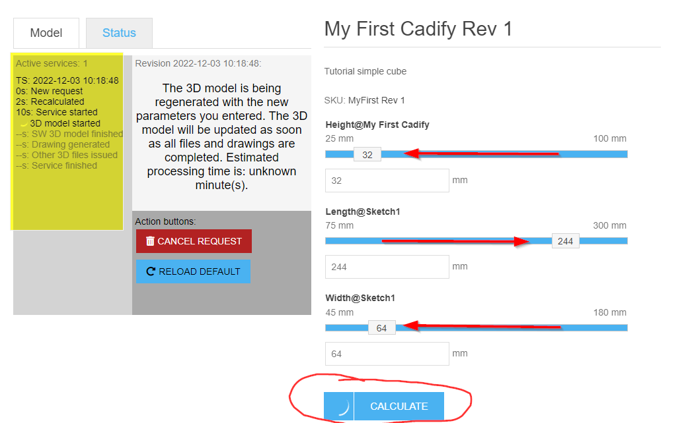

Here is the updated “My First Cadify”

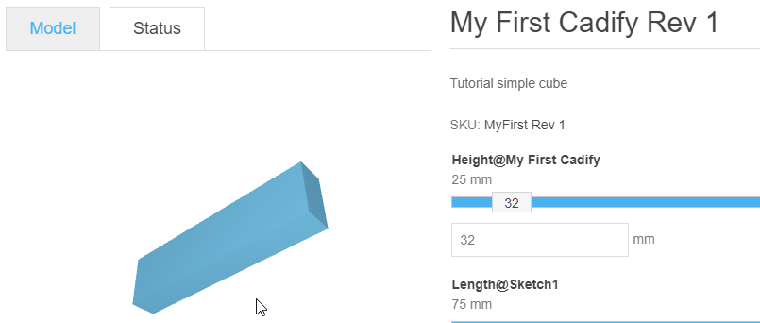

**3. Your First Drawing at www.Cadify.no**

**3.1 Reopen your Published Product to continue your work in Cadify**

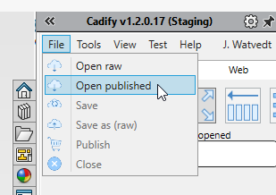

After a few seconds, you get a list of available Published products, sorted with most recent in the bottom of the list.

NOTE: We are currently working on the Cadify “staging” site, which mainly is for testing and verification. So there are a lot of other products there as well. You are welcome to take a look into other products, but, please, PLEASE, do not Re-publish other than your own product:

Go to Tools/Drawing/Create Drawing for a new drawing:

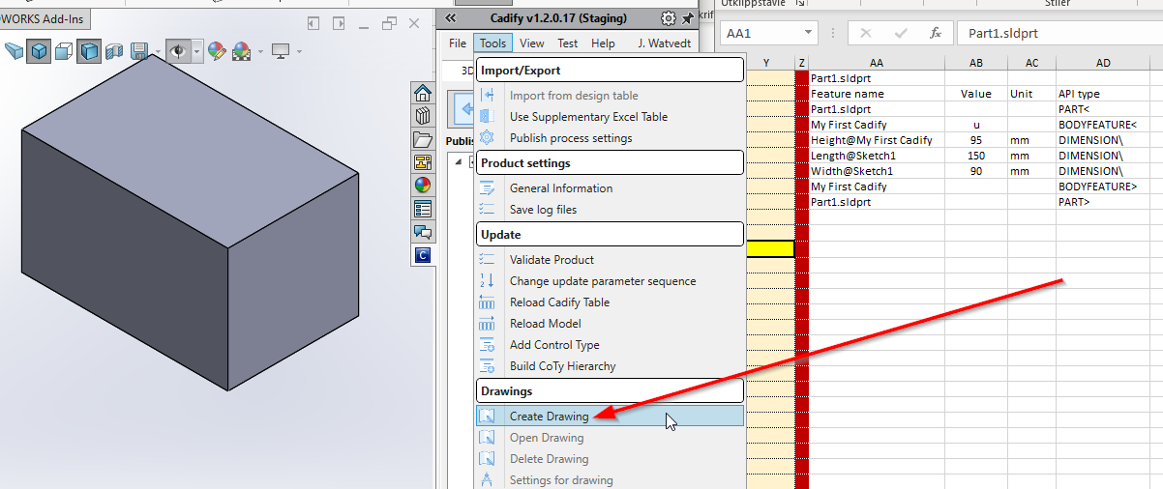

Work your way thru these (mostly obvious) selections: You can always just delete the drawing and try again if some of your choices did not work as expected. Initially, I suggest these simple and safe selections:

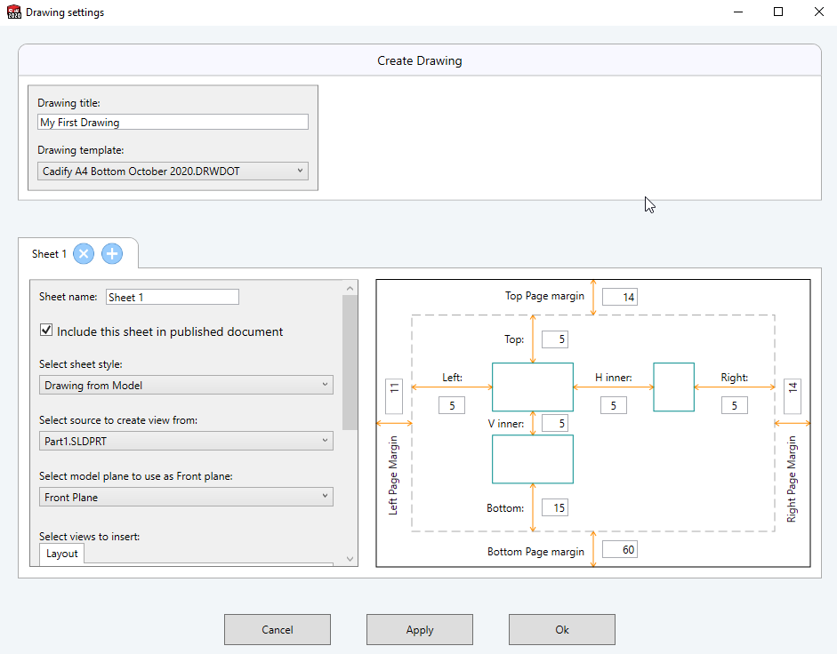

Drawing is automatically created as a 3-view drawing ( as you set in the Drawing Settings)

Label 1: Here is your drawing: Doesn’t look like much, but: Your Product is just a simple cube, so is your drawing, and initially there are no dimensions either

Label 2: In the Cadify Table there are no a complete specification for drawing settings. Some of these are just settings for use by Cadify, but you may also do a lot of manual editing and, more importently, use Excel formulas to manipulate drawing properties, notes and dimensions.

Label 3: Note that this takes place in the Drawing tab

Label 4: Here are the dimensions that you re-named in SolidWorks: next step is to select these dim’s for insertion into the drawing, as “model dimensions”. In future tutorial you will see how drawing dimensions are handled. There is also a Notes tab: There are different types of managed notes as well.

Selected dim’s are now managed by Cadify:

Label 1 shows checkboxes to select and un-select dims’s. Click on dim and that dim is highlighted in the drawing view, label 2, and when you place your curser in the spreadsheet, the corresponding section, label 3, is highlighted as well:

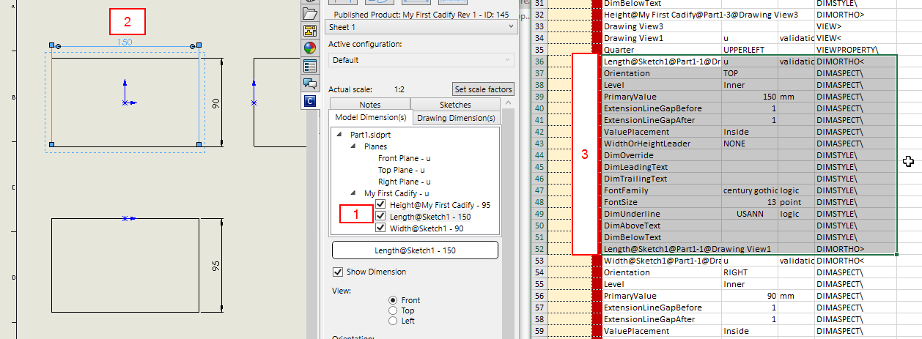

Select any dim in the drawing, and the Cadify Task Pane reflect the Selected Dim ( Example: Label 1) in the model dim tree label 2 and the Settings section header Label 3.

NOTE: The entire Label 4 is the settings you need to control dimension in the drawing. Just explore settings and observe what happens, and you will quickly get an idea how Cadify drawings are managed:

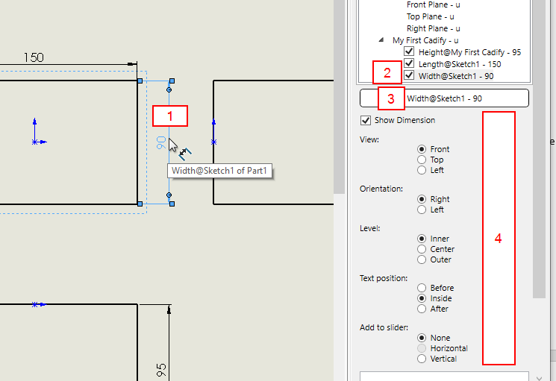

Play with the sliders, press the Update button, and enjoy the automated drawing response:

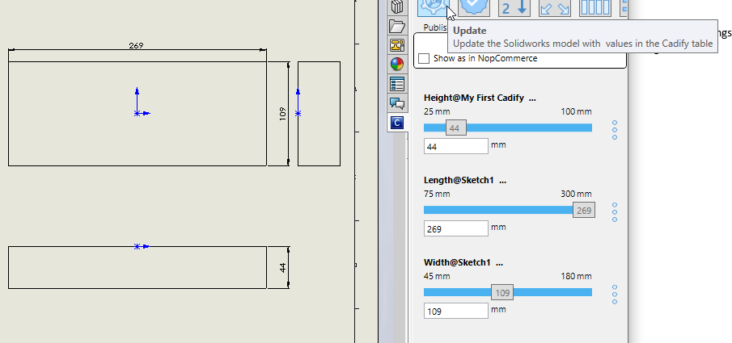

IF you would like to access your drawings directly from the web browser, then the access rights must be set in the Cadify Proxy:

In the “models” section, click on the “Add” button and do your best to fill in and select something similar to this:

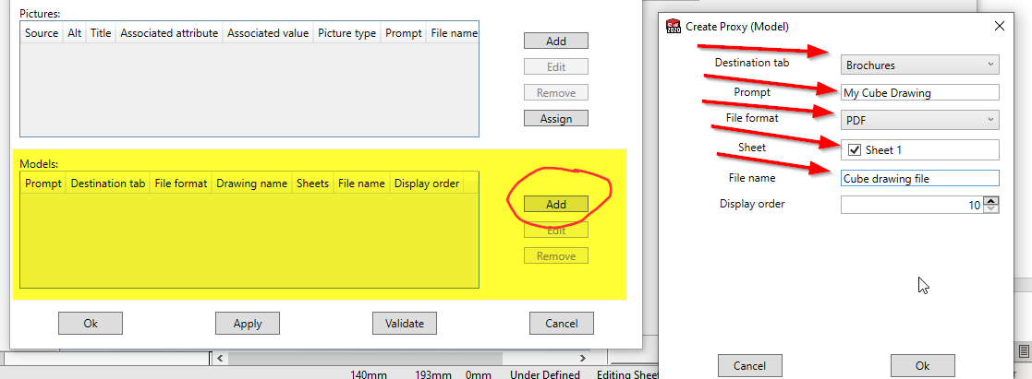

**3.2: RePublish your updated Product with Drawing**

Now is time to Re-Publish your Product, and see how this looks on the web.

IMPORTANT: Now that this Product is already Published, your option is to refresh current product, aka Re-Publish:

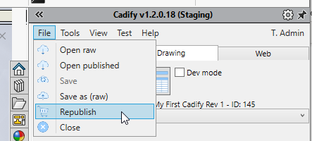

With new drawing and all, then this process takes a lot more time than initial simple cube: Here is the link to jump directly to the Re-Published product on web:

**3.3: Download your First Drawing from the Tabbed section**

In the browser, scroll down to the tab section, and you notice that there is a new tab with pdf file:

Download and Open: Doesn’t get more convenient than that:

THANK YOU FOR YOUR TIME!

Jørn Watvedt